**Question:**

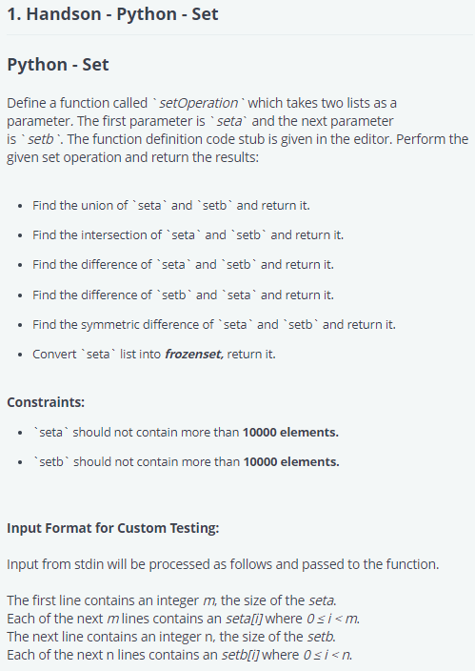

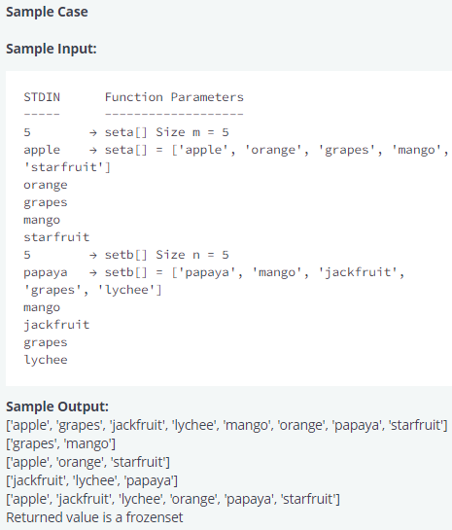

**Answer:**

def setOperation(seta, setb):

    # Write your code here

    seta = set(seta)

    setb = set(setb)

    fseta = frozenset(seta)

    return(seta|setb, seta&setb, seta-setb, setb-seta,seta.symmetric_difference(setb), fseta)

if __name__ == '__main__':

    seta_count = int(input().strip())

    seta = []

    for _ in range(seta_count):

        seta_item = input()

        seta.append(seta_item)

    setb_count = int(input().strip())

    setb = []

    for _ in range(setb_count):

        setb_item = input()

        setb.append(setb_item)

    un, intersec, diffa, diffb, sydiff, frset = setOperation(seta, setb)

    print(sorted(un))

    print(sorted(intersec))

    print(sorted(diffa))

    print(sorted(diffb))

    print(sorted(sydiff))

    print("Returned value is {1} frozenset".format(frset, "a" if type(frset) == frozenset else "not a"))

**Output:**

Input (stdin)

* **5**
* **apple**
* **orange**
* **grapes**
* **mango**
* **starfruit**
* **5**
* **papaya**
* **mango**
* **jackfruit**
* **grapes**
* **lychee**

Your Output (stdout)

* **['apple', 'grapes', 'jackfruit', 'lychee', 'mango', 'orange', 'papaya', 'starfruit']**
* **['grapes', 'mango']**
* **['apple', 'orange', 'starfruit']**
* **['jackfruit', 'lychee', 'papaya']**
* **['apple', 'jackfruit', 'lychee', 'orange', 'papaya', 'starfruit']**
* **Returned value is a frozenset**

Expected Output

* **['apple', 'grapes', 'jackfruit', 'lychee', 'mango', 'orange', 'papaya', 'starfruit']**
* **['grapes', 'mango']**
* **['apple', 'orange', 'starfruit']**
* **['jackfruit', 'lychee', 'papaya']**
* **['apple', 'jackfruit', 'lychee', 'orange', 'papaya', 'starfruit']**
* **Returned value is a frozenset**